Smart Refrigerator Concept Selection

Ideas considered for concept selection
Our group had a lot of ideas on how to execute building a mini fridge with a passive and active cycle. Some of the areas with the most variation were the fin and ice configuration, where in respect to the rest of the fridge would the fins, ice, and fans be located, as well as where to place our more complex control panel. During the concept creation phase, we had a lot of different ideas on how best to execute our envisioned project. However, there was a lot of overlap between designs, so it was quite easy to consolidate them to three or four well developed ideas. One way we consolidated or eliminated ideas was through evaluating the manufacturing cost. It was easy to get creative with different ice and fin designs, including circular tubes or curved banks of fins. However, once our group evaluated from a manufacturing perspective, some of our more abstract, yet efficient designs were eliminated.
After consolidating and eliminating ideas, we began to start discussing our options for the primary design decisions such as heat transfer shapes to contain our passive cooling ice block, control panel functions and placement, shelf designs, location and format of the control panel, and control panel location.

Control Panel Location
A control panel/apparatus is required for consumer use and monitoring. We plan to have a very simple setup where a user can see when their refrigerator is running an active/passive cycle, and we also plan to add a way for them to possibly override the passive cooling if desired. The control panel could be located on the front of the fridge, on the door of the fridge inside, or above the fridge door. Figure 1 shows three possible locations for our control panel.

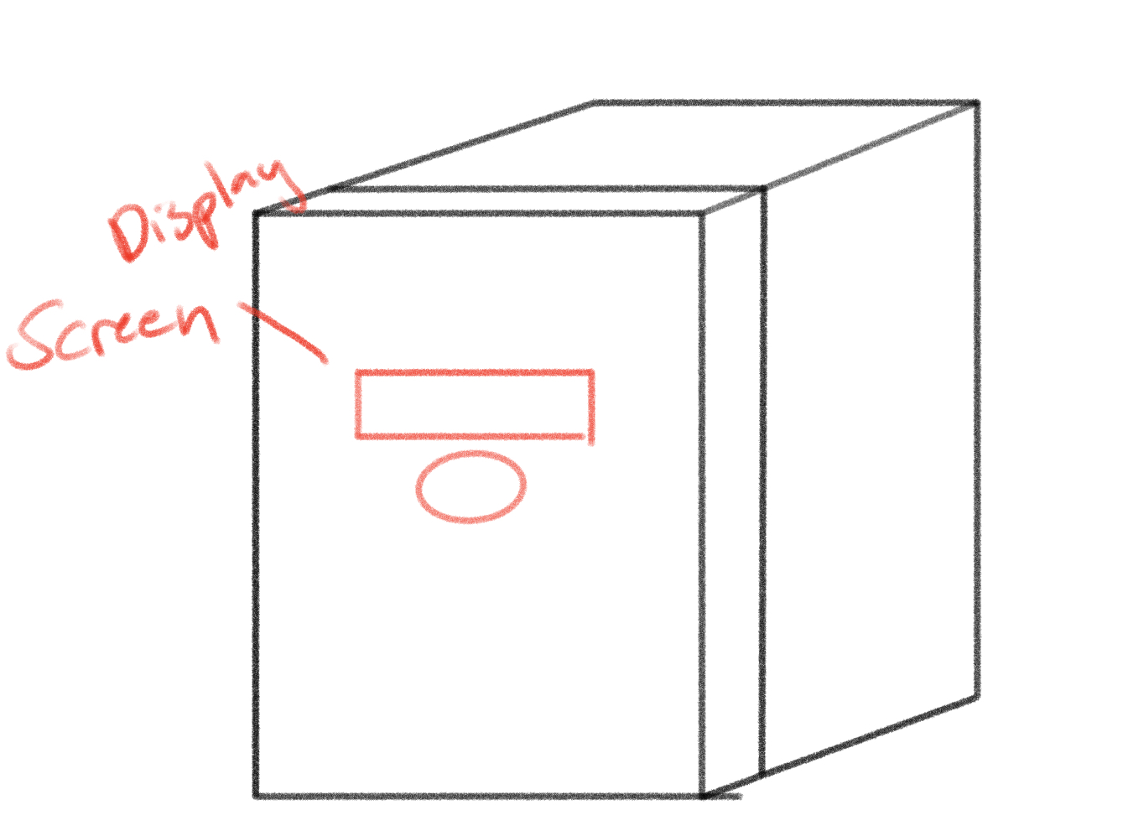 | 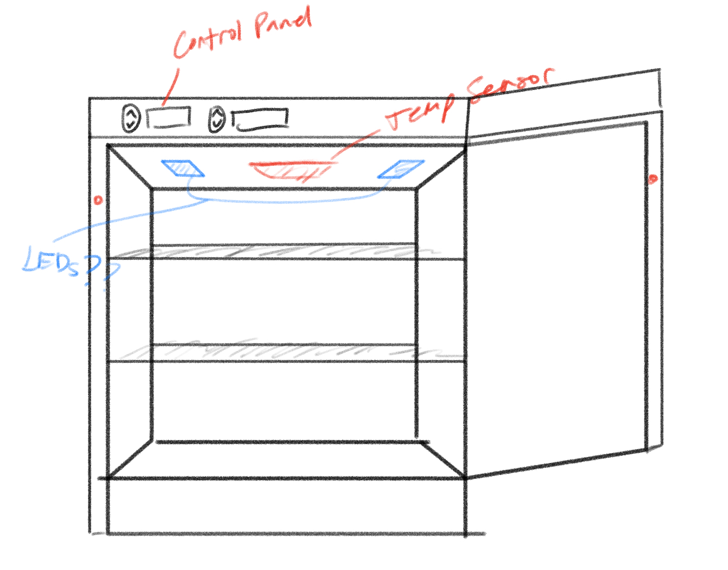 | 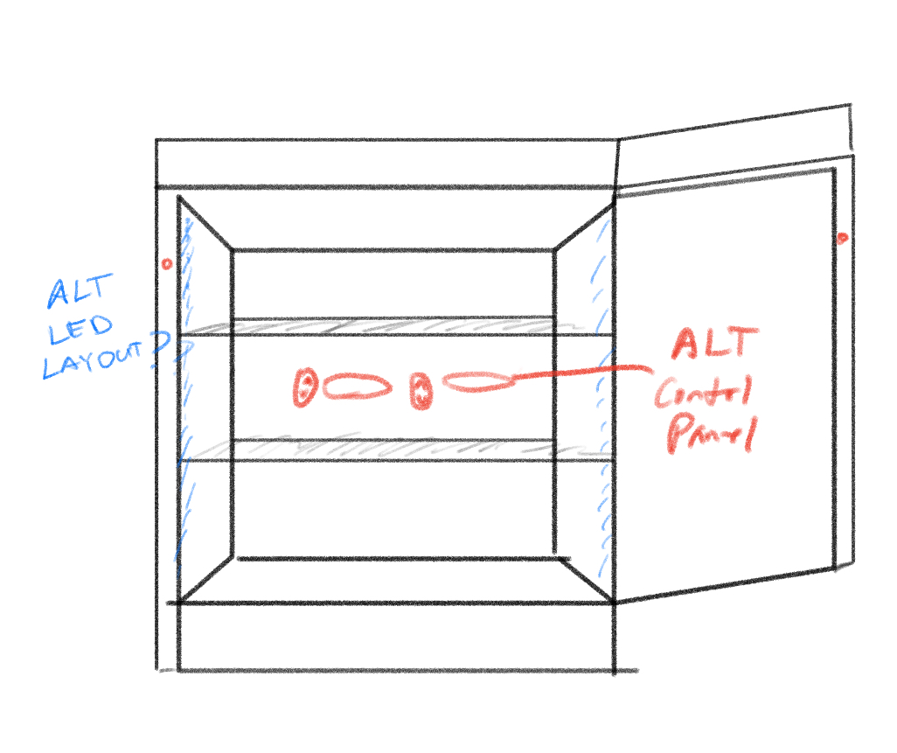
Figure 1. Alternative placement locations for refrigerators control panel

Control Display Layout
In our initial concept generation, we only had one concept generated for our potential control panel display layout as seen in Figure 2, so we just discussed how we would modify it to ensure we knew exactly what we wanted for our final design. To meet customer needs and make our fridge user friendly, a good control panel is needed, so we considered using lights, seven segments, or a LED screen.
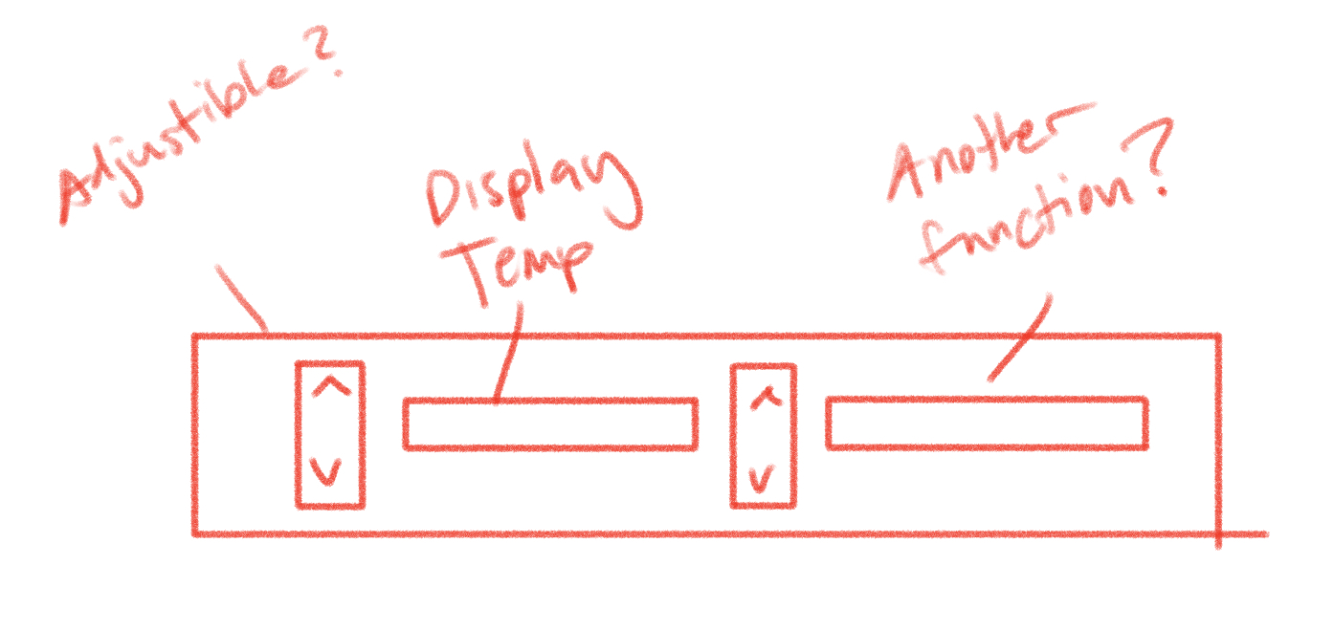
Figure 2 - Potential Display layout 1

Shelf Layout
During our customer needs survey, shelving and interior space was the most important metric for all respondents. Practically speaking, consumers want refrigerators to store food, so high-volume and convenient storage is important. With that said, the easiest way to optimize space for the consumer is to find an ideal shelving layout for our fridge. We introduced two options shown in figure three that have promise. Option one contains two bottom shelves, one large shelf, and one narrow shelf where option two contained two removable shelves, one drawer, a compartment for compressor/refrigerator components in the back, and rails for shelf adjustment.

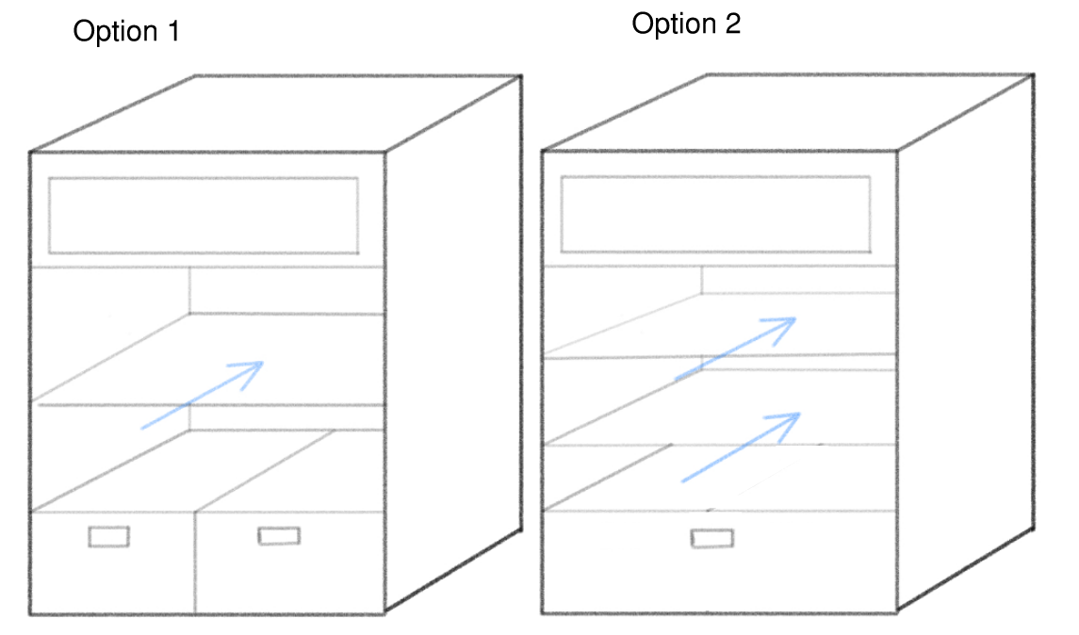
Figure 3 - Shelf Layout Options

Heat transfer Design
For the passive cooling cycle to provide effective cooling, air from the refrigerator must be cycled through a freezer compartment and cooled to below refrigeration temperature before it re-enters the refrigeration compartment. For cooling to occur, the air must interact with a medium that is at a lower temperature than the air itself such as ice. Only blowing air over ice would decrease the temperature of the air but is limited by the surface area. To increase the surface area and therefore improve the amount of heat transfer that occurs, fins made out of a highly conductive metal can be used. All blocks of ice will be similar to ice packs such that there will be water sealed inside a case with a gap of air so that the water can expand when it freezes and be contained when it melts.

We generated many different concepts for the form of the heat transfer component and created CAD models to better visualize and evaluate the designs. These concepts were constrained by whether the freezer compartment was located on top of the refrigeration compartment, increasing the refrigerator’s height or behind it, increasing the required floor space. Design 1 and Design 2 shown below in Figure 5 showcase the configuration where the freezer compartment is located on top of the refrigerator. Design 1 has one large slab of ice with a panel of fins located on the top and bottom. There would be a metal plate that constrains the air to flow either above or below the ice block through the fins. Design 2 is similar but instead uses several thin sheets of ice rather than one large block. This allows for more surface area to install fins and allow for air to flow through.

Design 3 through Design 5 showcase the configuration where the freezer compartment is located at the back of the refrigerator. Similar to Design 2, Design 3 includes several thinner sheets of ice with fins between. However, in Design 3 the sheets of ice are vertical. Though the vertical design allows for more surface area for heat transfer to occur, ice freezes much faster when it is placed in horizontal configurations. For this reason, Design 4 and 5 direct the airflow in a serpentine pattern such that the slabs of ice can be placed horizontally. Triangle wedges are used in the corners to decrease the backflow and pressure drop. Design 4 uses rectangular while Design 5 uses circular tubes.

Design 1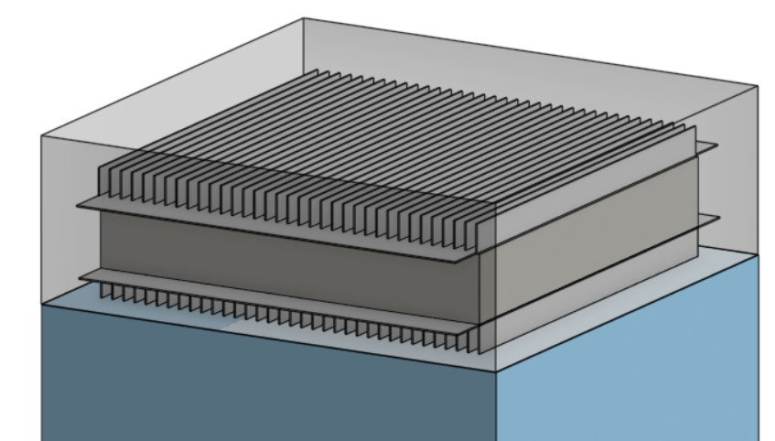 | Design 2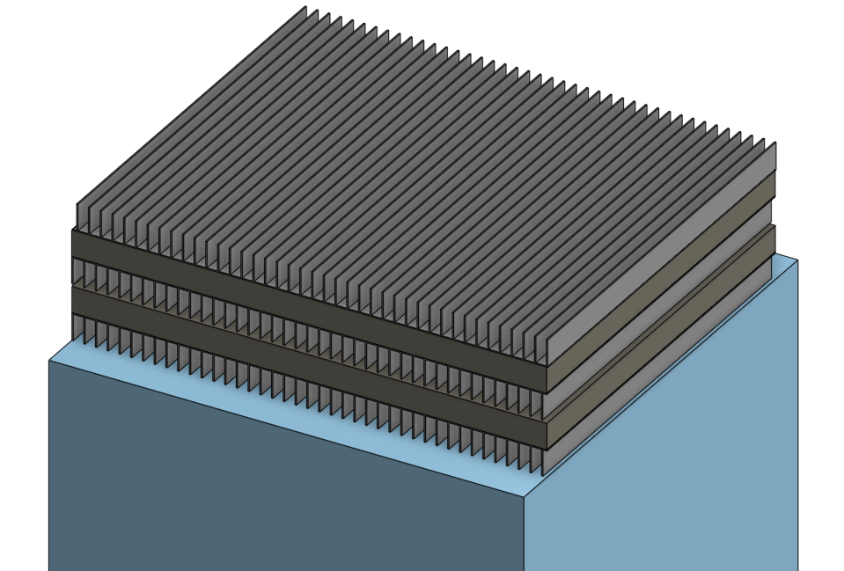
Design 3  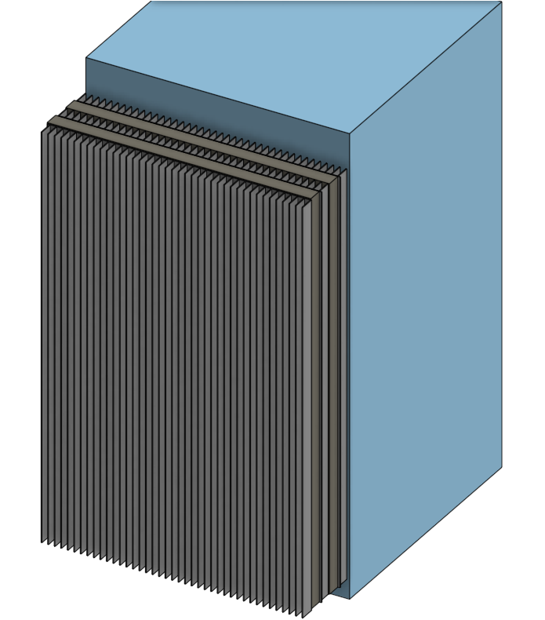 | Design 4  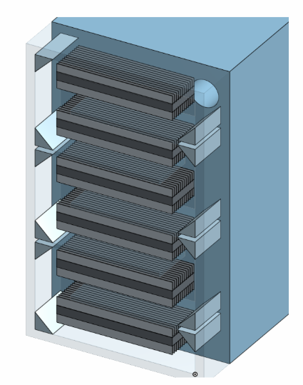
Design 5
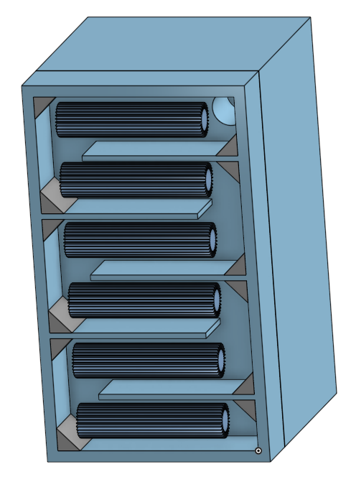

Figure 4 - Heat transfer layout options

Decision Method used

Heat transfer
To choose which design was best for the heat transfer between ice and air, we used a Pugh matrix shown below in Table 1. We wanted to zero in on only the most relevant criteria that would affect feasibility of the project, such as manufacturability, efficient use of space, and heat transfer effectiveness. In terms of manufacturability, we found that most fins that can be purchased are meant to be installed on flat surfaces. This means that wrapping fins around a circular tube such as in Design 5 would be very difficult. Furthermore, we recognize that the serpentine pattern in Design 4 and 5 would be more challenging to construct compared to the simpler stack configuration in Design 1-3.

Since the passive cooling system relies on having a block of ice, the water must be frozen during the active cooling mode. To provide a net negative in energy consumption, the ice must be frozen and with as little energy as possible. For this reason, one of our criteria in the Pugh chart is how quickly the ice will freeze. This is dependent on the thickness of the block, the shape (rectangular vs circular) as well as the orientation of the block (horizontal vs vertical). Since Design 2 and Design 4 used thin, rectangular blocks that were horizontal, they had the best ice freezing rate and were awarded positive points accordingly. Though Design 1 is also rectangular and horizontal, freezing one large block rather than multiple thin layers will take longer.

Another aspect of the effectiveness of our refrigerator is how much electricity the system will consume during peak hours while the system is in passive cooling mode. During this mode, the only component that will be active is a fan that pushes air through the freezer compartment to decrease its temperature. The size of the fan will be dependent on the airflow pattern as well as how much surface area is available in the fins for heat transfer to occur. Design 1-3 all have simple airflow patterns which is ideal. The serpentine aspect of Design 4 and 5, however, is poor for airflow and would require a larger motor on the fan to overcome the loss in static pressure due to the turbulence in the turns. The size of the fan is also dependent on the fin surface area because increasing the surface area that is available for heat transfer to occur will cause the outlet temperature to be lower. The refrigerator will require less air circulation if it is supplied at a cooler temperature, allowing the fan to run at a lower speed and draw less electricity. For this reason, Design 2 - 4 which all had thin layers with lots of fin surface area are more desirable for our final design.

Finally, the amount of space that the freezer compartment requires is very important as it relates to the amount of usable interior storage space given a limited exterior size. From our evaluation of customer needs, it is clear that adequate interior space is very important for our customers. Since the ice blocks in Design 1-3 are pressed between fins with no wasted space or additional structure required, they make the most efficient use of space compared to Design 4-5. From the Pugh Chart, it is clear that the most ideal design is Design 2 with 5 points followed by Design 3 with 4 points. For this reason, we have chosen to move forward with Design 2.

Table 1: Pugh matrix for Heat Transfer Shapes
Criteria | Baseline/  Datum | Design 1 | Design 2 | Design 3 | Design 4 | Design 5
Ice freezing rate | 0 | 0 | +1 | -1 | +1 | -1
Fin Surface Area | 0 | -1 | +1 | +1 | +1 | 0
Manufacturability | 0 | +1 | +1 | +1 | 0 | -1
Efficient Use of Space | 0 | +1 | +1 | +1 | 0 | 0
Airflow Pattern/Static Pressure | 0 | +1 | +1 | +1 | -1 | -1
Total |  | 2 | 5 | 4 | 1 | -3
Rank |  | 3rd | 1st | 2nd | 4th | 5th

Control Panel
One of the main methods we used to determine the location of the control panel was to insert images from our concept generation into this document, organize them to better understand our options for each concept, and discuss what we think would work best for us in conjunction with our customer needs. Since we unanimously agreed that the best location for the control panel was located inside the refrigerator near the top of the refrigeration compartment, we didn’t need to use a decision making tool such as the Pugh Matrix.

To decide which indicators and controls should be included, we discussed the necessary interactions required between the microcontroller and the user. Since temperature control was not highly prioritized in our customer needs, we decided the control panel did not need up or down arrow buttons. The only inputs that are crucial for operation are that the user can tell the refrigerator when their utility rates and set the clock to accurately match the local time. The additional display features were then evaluated based on how crucial they were and what the user would like to know to troubleshoot any issues they encounter.

Shelf layout
To evaluate all of our shelf layout options, we placed the images side by side and discussed the pros and cons of each option. We once again referred to our customer needs and the importance of both the interior storage space and flexibility in shelving layout. When narrowing down our shelf design options, we also took into consideration the current shelf design of the broken mini fridge that we will be using as a starting point for our construction.

Final Concept
The final fin and ice configuration our group decided on was Design 2 for the freezer compartment. We chose this design using the Pugh chart as it had the highest score due to the high fin surface area, ideal freezing time, good airflow, efficient use of space and ease of constructability.

Figure 5 - Final design choice for fin and ice configuration

For the control panel configuration, we opted to not have user input for temperature. Because of the nature of our design, our refrigerator will not have a freezer, it will only keep things cold, so we felt user input was redundant to set temperature, our smart refrigerator will be programmed to maintain an internal temperature of 37 degrees fahrenheit. We did deem it important that our control panel will display the internal temperature. We also concluded it necessary for the control panel to indicate whether our project is on its active or passive cycle, which will be done with LED lights.

Lastly, for the user to configure when they want the passive cycle to run, we concluded on a design similar to conventional alarm clocks. We will have three time setting buttons, and two time adjustment buttons. The two time adjustment buttons are ‘hour’ and ‘minute’ and will be used to move the time around. The ‘clock set’ button will be used to set the primary clock time, this is the time that the passive cycle will start and end on. The user then will choose when they want the passive cycle to start and end. After discussing all the necessities for our control panel display, we came up with the display layout in figure 6.

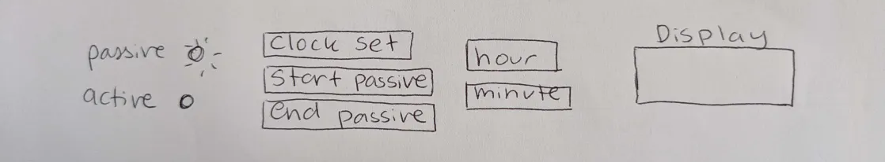
Figure 6 - Final control panel configuration

We also ultimately determined that the control panel should be placed on the top inside lip of the fridge as this is most custom and what most users are used to already as shown below in Figure 7.

Figure 7 - Final control panel location

For the shelving configuration, we decided to have two removable shelves and one single large drawer at the bottom shown below in Figure 8. This allows for the user to customize their refrigerator layout to best suit which items they regularly purchase and store. Furthermore, the single larger drawer rather than the two smaller drawers is better suited for our design because of the scale of the mini refrigerator we are working with.

Figure 8 - Final shelf configuration

